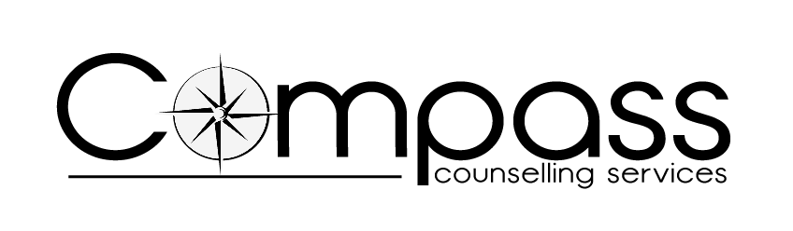

employee assistance program

Service User contract

Registered Charity Number: 700335
Company Limited by Guarantee: 2235061

Organisation Details

Company Name

Address & Post Code

Telephone Number

E-mail

Contact Name

Position

How many employees do you have at the present time?

What is the nature of your organisation?

Counselling details

How many counselling sessions would you like to offer your employees?
Specific requirements
For example:
Location
Times
DNA Notification
Department
Employee pass
Other…………

Referral Details

Method of referral

CONTRACT DETAILS

Commencement date of contract: | Note: Contracts and their content will be reviewed annually

Assessment & Counselling – The Counselling Service Manager will contact the client in order to complete a referral and will then arrange for an appointment for the client to see one of our Counsellors. The same Counsellor will undertake both the assessment interview and the subsequent sessions. Sessions will last for 50 minutes and will take place at the same time each visit, usually on a weekly basis.

Counselling Model – The COMPASS counselling model is a Relational one, which is an integration of Person Centred counselling and aspects of the Psycho Dynamic model.

Maximum Sessions – Compass will deliver …….sessions (one assessment) to the client. However, because of the particular nature of an individual’s problem, it may be considered suitable to offer additional sessions. In this event, the employer will be contacted in order to negotiate additional sessions.

Fee – Sessions are charged at £65 for both the assessment, for subsequent sessions thereafter, these costs are reviewed annually. Payment of invoices should be made within the requested timescale.

Cancellations – We require 24 hours’ notice for cancellations. Cancellations made before the 24 hours notice period will not be charged and appointments may be re-booked. Dependent on the circumstances, cancellations made with less than 24 hours notice or if a client fails to attend, may incur a charge.

Insurance – Compass will indemnify your organisation against any claims made regarding the service that we agree to provide and any claims made for injury whilst on our premises.

Confidentiality – All of our counsellors work to the BACP Ethical Framework for Good Practice in Counselling and Psychotherapy in relation to issues of confidentiality. Copies of this are available upon request.

Restrictions – Compass are only able to provide counselling for employees who are over the age of 18.

Complaints Procedure – A copy of our Complaints Procedure is available upon request.

Feedback – Information may be negotiated but only in the form of general trends, issues and the level of service provided.

Review Date – Compass will contact you again before the contract expiry date to discuss and review how this service has helped your organisation.

=================================================

I agree to the procedures outlined within this contract

Name: | Signature:
Position: | Date:

Signed on behalf of COMPASs
Name: | Signature:
Position: | Date:

