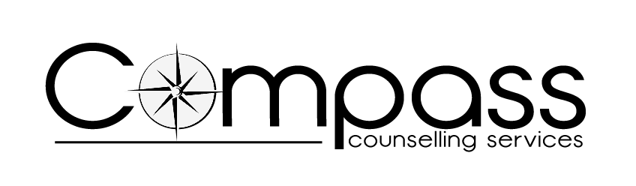

Application Form – Level 3 Certificate in Counselling Studies (CST-L3)

Name: (Please use block capitals and print your name as you wish it to appear on your certificate)

Address & Postcode:

DOB: (Must be 19+) Age:

Which gender do you identify with? Male □ Female □
Prefer not to say □
Preferred pronouns - Him/He □ She/Her □ They/Them □
Prefer not to say □ Other, please specify: ____________________

Mobile No:

Email Address:

In case of emergency, please contact:

Name: Relationship to Student:

Contact No:

Reasons for applying:

Relevant experience in a helping/supporting role:

Relevant Qualifications: (Name of course)

Examining Board: Date:
(Please note that you must hold a Level 2 Certificate in Counselling (or equivalent) in order to apply for this qualification)

What have you learned about yourself following Level 2?

How has this impacted your personality?

Are you able to access Zoom? |  | YES/NO | Do you require large print handout? |  |  | YES/NO
Do you require wheelchair access? |  | YES/NO | Other additional learning needs – please specify:
Examining Board diversity requirements:
Cultural origin/ethnicity: |  |  | Difficulties/disabilities:
How did you hear about this training course?
Referee 1: Level 2 Tutor |  |  |  | Referee 2:
Name: |  |  |  | Name:
Position: |  |  |  | Position:
Organisation: |  |  |  | Organisation:
Address: |  |  |  | Address:
Tel No: |  |  |  | Tel No:
Email Address: |  |  |  | Email Address:

The majority of this course will be held at LCVS in Dale Street, Liverpool City Centre. Tutorials will be help via Zoom.
If you are accepted onto this course, please indicate your agreement to the above and the course fees as follows:
Course fees £1206
Examining Board Registration Fee £189
Total Cost £1395 I agree to the stated fees

I enclose the fee of £ (please make cheques payable to Compass Counselling Services)

I have paid via BACS transfer the fee of £ Sort code: 08 92 99
Account No: 67242238

Please arrange to call me to take my debit/credit card details

I agree to pay £150 deposit, refundable in the event of the course not taking place or my application being unsuccessful and the following:

£750 upon commencement of the course (this includes £189 Examining Board registration fee which is non-refundable once the course begins) and the balance of
£495 week commencing 6 January 2025

Name: Signature:

Date:

Please return your completed Application Form to:

Compass Counselling Services
151 Dale Street
Liverpool
L2 2AH

Email: enquiries@compass-counselling.org.uk

